International Day for Disaster Risk Reduction

Observance – 13th October 2021

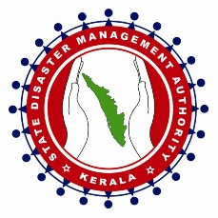

Organized by

Kerala State Disaster Management Authority

Introduction

As part of the observance of International day for Disaster Risk Reduction(IDDRR), a meeting was organised in the office premises for all officials of KSDMA on 13th October 2021. Dr. Pratheesh C Mammen, Programme coordinator, UNICEF welcomed the participants and key speakers. Mr. Baiju G, Administrative Manager, KSDMA presided over the meeting. In his brief presidential address, he focussed on the observance of such days in the current context of change in climate patterns.

Mr Anilkumar V, Member secretary(i/c) inaugurated the meeting. He detailed the growth and history of disaster management mechanism in Kerala and reiterated the fact that disasters and disaster risk reduction are becoming part and parcel of our life unlike in the past. Following his address, Mrs Kumari Shirley, Office Manager, KSDMA delivered felicitations.

Session Details

Mr. Joe John George, State Project Officer, delivered the keynote address explaining the theme of this year’s observance. The Sendai Seven Campaign as part of the IDDRR is in its 6th year following its launch by the UN Secretary-General in 2016. Each year, the focus has been on one of the seven targets of the Sendai Framework agreed by UN Member States at a World Conference on DRR in Sendai, Japan. The focus of this year’s International Day for Disaster Risk Reduction is on Target (f): “Substantially enhance international cooperation to developing countries through adequate and sustainable support to complement their national actions for implementation of the present Framework by 2030.” Seven targets, four priorities and 38 indicators were introduced to the participants in the key note address. He also stressed the need of an inclusive strategy for all disaster risk reduction activities. The meeting concluded by the Q & A session and was followed by a working lunch for all the attendees. All officials present in the office of KSDMA and SEOC participated in this occasion.

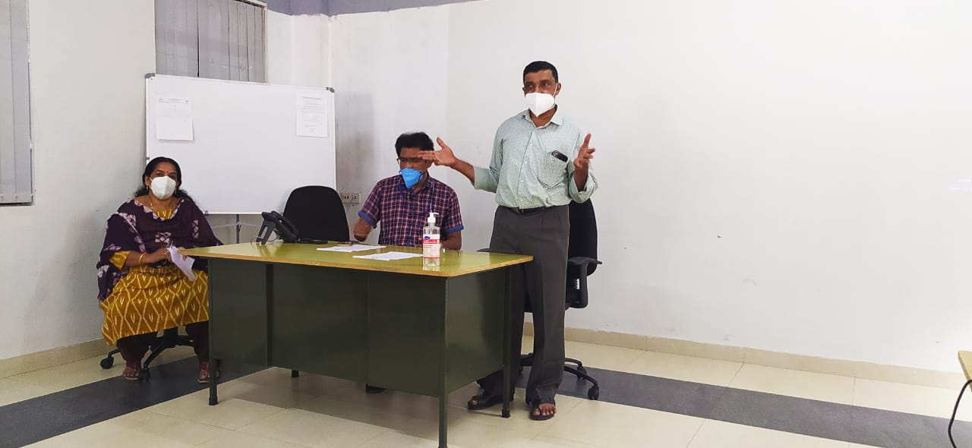

Mr Anil Kumar, SFO (Member Sec’y, i/c) delivering the inaugural address

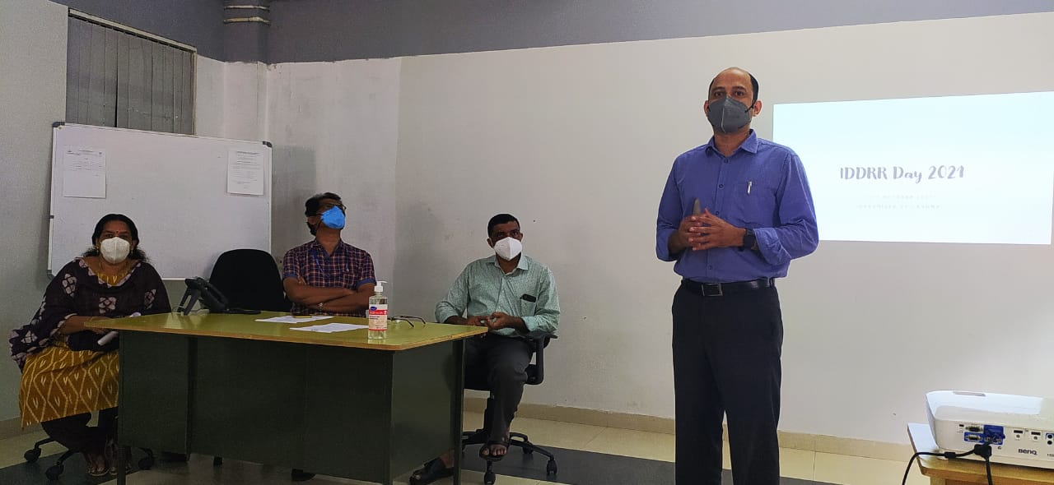

Mr Joe George, delivering the keynote address

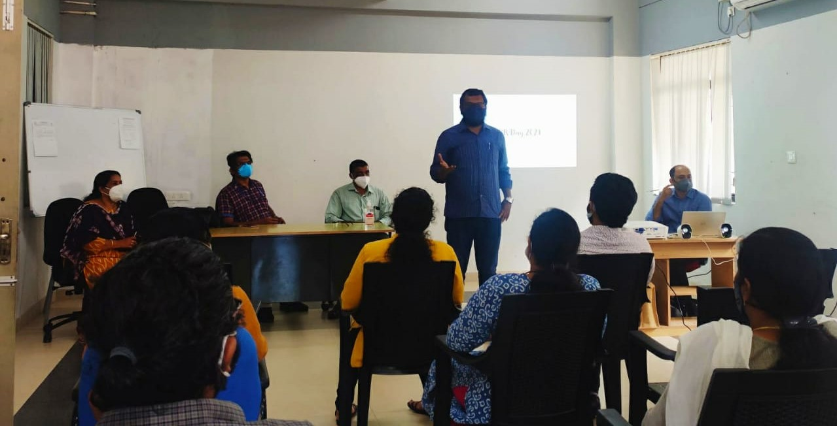

Dr Pratheesh Mammen addressing the participants

