Report of ‘Fire Safety Awareness’ Program

Date: 8th February 2022
Time: 03:00 pm to 04:00 pm
Plat form: Cisco WebEex

Organized by
KERALA STATE DISASTER MANAGEMENT AUTHORITY

Report of the Training
A fire can result in the loss of life and jobs. The Fire safety training is an important strategy for maintaining a safe place and preventing fires. The coming months (March-May) are very prone to fire accidents. In order to prevent it from happening, Kerala State Disaster Management Authority (KSDMA) organized a webinar to present its activities associated in disaster risk reduction due to fire. The objective of the webinar served both to disseminate the knowledge and to receive feedback and gather inputs on activities and improvements for future work of KSDMA.
The fire safety training was held on 8th February 03:00 pm to 4:00pm IST which was organized for public. The session was attended by around 70 people. The session was an introduction to the basic fire safety awareness which include different type of fire and fire extinguisher classification. Also, the session focused on how to handle an emergency situation including dos and don’ts.
The programme was hosted KSDMA. Mr. Clint Mathew, Capacity Building Specialist, KSDMA opened the meeting and welcomed the participants. The session was conducted by Mr. Adharv Suresh, Safety Engineer, KSDMA. The session centres about the vulnerable areas of the fire accident and how to handle it properly without any damage to life.
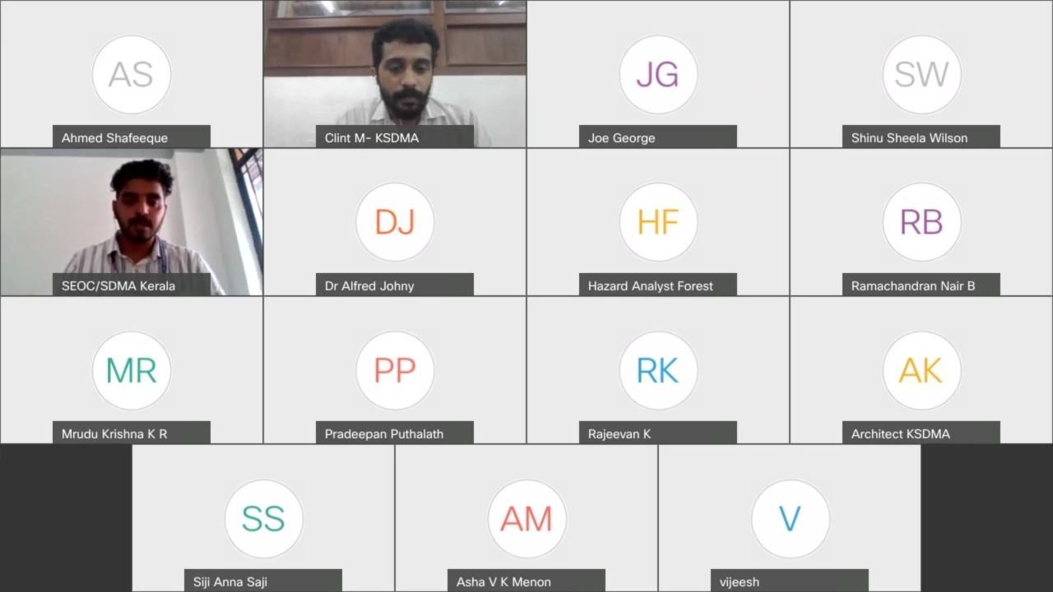
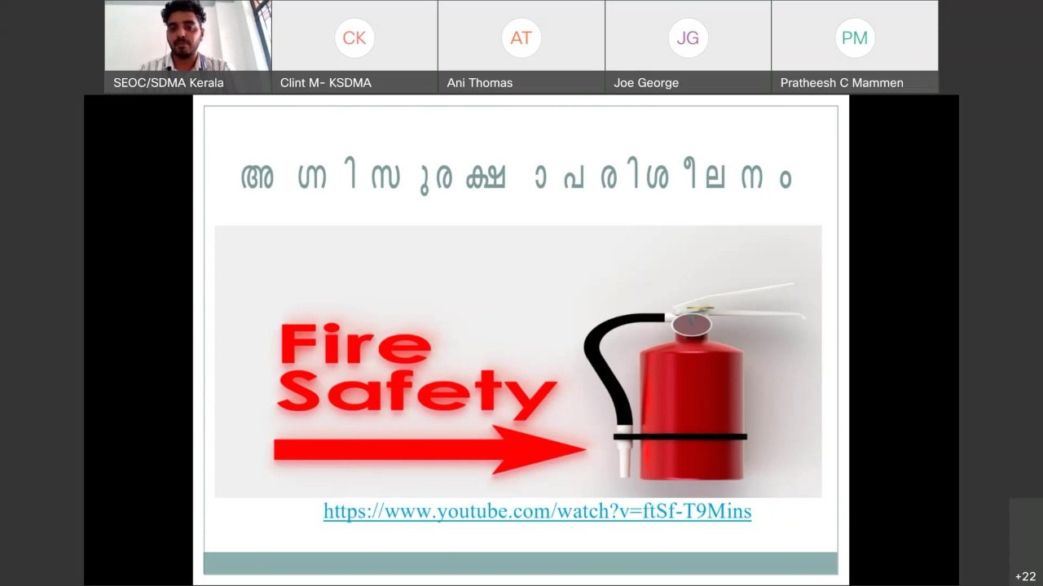
Participants List
SL No | Name | Attendee Email
1 | Clint M- KSDMA | clintmanjappallil@gmail.com
2 | SEOC/SDMA Kerala | seoc.gok@gmail.com
3 | Dr Alfred Johny | alfredjohny07@gmail.com
4 | Joe George | mailstojoe@gmail.com
5 | Hazard Analyst Forestry | haforestryksdma@gmail.com
6 | Mrudu Krishna K R | mrudukrishnakr@gmail.com
7 | Ramachandran Nair B | brcnairsrm@gmail.com
8 | Architect KSDMA | arcksdma@gmail.com
9 | Chandini | haeconomicseoc@gmail.com
10 | Lekshmi v | ksdmahydrologist@gmail.com
11 | Shinu Sheela Wilson | shinusheelawilson@cusat.ac.in
12 | vijeesh | mailstovijeesh@gmail.com
13 | Rajeevan K | rjeevancusat@gmail.com
14 | Ani Thomas | anithomas777@gmail.com
15 | Pradeepan Puthalath | pradeepanputhalath1619@gmail.com
16 | Remya R | rr.remya22@gmail.com
17 | VH | vijithh@gmail.com
18 | Kevin Stellus | kevinstellus@gmail.com
19 | Santhosh KS Nair | sksnairkollam@gmail.com
20 | Vijayalakshmi Palat | vijipalat2011@gmail.com
21 | Asha V K Menon | ashakannan44@gmail.com
22 | Fahad Marzook | fahadmarzook@gmail.com
23 | tina | teenamathew913@gmail.com
24 | SABIRA | sajidkazrod@gmail.com
25 | Aiswarya | aiswaryasathianadhan@gmail.com
26 | Ashhar Jabbar | ashharjabbar@gmail.com
27 | Rajesh CP | ceepee.pnr@gmail.com
28 | Selvaraj | selvaraj6451@gmail.com
29 | sreelekshmi. m. d | sreelekshmi2070@gmail.com
30 | Sriram A | sriramananth12@gmail.com
31 | Sunil | sunilkooriyad@gmail.com
32 | Tinoj John | tinojjohn@gmail.com
33 | Soorya Nair | sooryanair7892@gmail.com
34 | Sachu Sasindran | sachues6@gmail.com
35 | Siji Anna Saji | sijianna22@gmail.com
36 | Praveen P U | prvn949@gmail.com
37 | Rajeevan K | jeevancusat@gmail.com
38 | John | rt4188@gmail.com
39 | Binu perumana | ullanadbinu@gmail.com
40 | ATHIRA V M | vmathira1994@gmail.com
41 | Pratheesh C Mammen | pratheeshcmammen@yahoo.com
42 | neethu thomas | neethuvt0503@gmail.com
43 | BR | ashwinrajnileshwar707@gmail.com
44 | Gauri Ghosh | ghoshgauri007@gmail.com
45 | Ahmed Shafeeque | ahammedsp111@gmail.com
46 | Siji Anna Saji | sijianna22@gmail.com
47 | NAYANA. N 9 B | s12024.7262@kiteschool.in
48 | sujala | sujalap59@gmail.com
49 | satheesh p | sutheeshp7@gmail.com
50 | Alan&Angel jose | susmijose0@gmail.com
51 | Basil P. V. | postforbasil@gmail.com
52 | RISWANA | riswanakmajeed@gmail.com
53 | SREERAAG E V | ssreerag692@gmail.com
54 | Ahmed Shafeequeq | ahammedsp111@gmail.com
55 | shyamjith. P | shyamjithp2007@gmail.com
56 | SREERAAG E V | ssreerag692@gmail.com
57 | sameera p | sameera.p4@gmail.com
58 | Praveen P U | prvn949@gmail.com
59 | Aswin Vinod | aswinvinodktm@gmail.com
60 | Gauri Ghosh | ghoshgauri007@gmail.com
61 | SEOC/SDMA | seoc.gok@gmail.com
62 | Anjaly Parameswaran | anjalyvis@gmail.com
63 | Gauri Ghosh | ghoshgauri007@gmail.com
64 | Noushaba Nas | noushabanas@gmail.com
65 | SREERAAG E V | ssreerag692@gmail.com
66 | Sreenanda TV | moolayadukkamnarayananp@gmail.com
67 | Vineesh V | vineeshvc@gmail.com
68 | Abhi | abhijith777.vs@gmail.com
69 | Hazard Analyst Forestry | haforestryksdma@gmail.com
70 | Vijith H | vijithh@gmail.com

